Dynamic Traffic Light Control

Guide :Prof. P. M. Bagul.

Domain : Embedded Systems, IoT

RohitTondare

RahulnarayanIyer

AdityaUndre

AkankshaPatil

**Abstract :**

       In recent era, due to the increase in population and the number of vehicles bought, there is  a problem of congestion of traffic in the major cities around the globe. This not only increases the time delay but also increases the fuel consumption and air and noise pollution. It is observed that conventional traffic flow is intricate and non predictable. Furthermore emergency vehicles like ambulances, fire trucks etc. are delayed. This project aims to solve the aforementioned problems by implementing real time control of the traffic signals using Image Processing, IoT and Object detection. Embedded Systems are small and can be integrated with the existing infrastructure in order to reduce the cost and complexity.

**Introduction :**

Automobile is a great invention for people to travel and extend their reach. Unfortunately, in recent times the increasing number of vehicles can cause a series of economical and social problems. However due to limited availability of land, the roads cannot be widened to suit the traffic needs.  Conventional traffic light systems use a fixed cycle of predefined pattern to control the dynamically changing traffic flow. Dynamic Traffic Light Control refers to the control of flow of traffic via the signals in real-time.

**Survey :**

In our personal interview with the DCP of Traffic, Pune, he mentioned that currently there is a huge lack in infrastructure in our city. The road and signal infrastructure is not able to cope up with the rapid growth in the number of cars. The number of vehicles is increasing but the width of the roads is stagnant. As there are a lot of malls and buildings, increasing the width of the roads is not possible. Therefore a system is needed that will that will allow the movement of these vehicles in an organized manner.

**Motivation :**

It commonly occurs that, at a particular intersection there is high density of traffic in one lane and there is very low density of traffic in the others. Despite that, the green time for all the lanes are the same. Another major problem is the excess waiting time for emergency vehicles. Due to the static nature of current system, there is no easy way to detect emergency vehicles. Therefore we are inclined to design a system that will detect the lane with highest traffic and make its signal green. In case an emergency vehicle is detected that particular lane will be given highest priority until the emergency vehicle has passed.

**Proposed Work :**

In order to reduce the waiting time at a signal, we are proposing the use of Dynamic Traffic Light control with the help of Image Processing, IoT and Object detection. The major data will be collected from the existing from the existing CCTV cameras. With the help of the data from the CCTV cameras, Emergency vehicles also will be detected. With the help of this system, there will be no waiting time for Emergency vehicles. There will be intercommunication between signals at adjacent intersections as well as between the signals at an intersection in order to have a full interconnection and synchronization in the system.

**Methodology :**

We will be calculating the traffic density with the help of the current CCTV footage which will be supported by Google maps traffic data.

The communication between two signals will be done with the help of ESP8266 Node MCU. We will then obtain the traffic density in each lane. Whichever lane will have highest traffic density will be given priority over other lanes and its signal will be made green. At the same time the traffic signals at an intersection will be interacting/ communicating with each other so as to know the amount of traffic coming its way. Based on all this data which signal has to be made green next is decided.

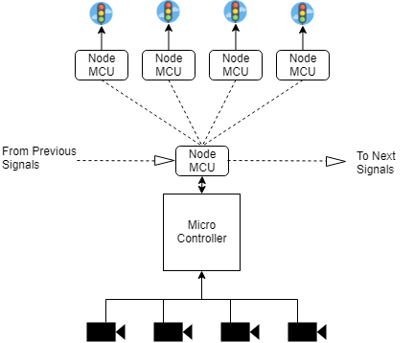

**Expected Outcome :**

By implementing this system we expect the following:

* + Reduction in congestion of vehicles
  + Less delay in reaching a destination
  + Fewer accidents
  + More priority to emergency vehicles

**References :**

1. Sarath S and Deepthi L.R, *"Priority Based Real Time Smart Traffic Control System Using Dynamic Background"*, 2018
2. Md. Munir Hasan , Gobinda Saha , Aminul Hoque and Md. Badruddoja Majumder ,*“Smart Traffic Control System with Application of Image Processing Techniques”,* 20114
3. Md. Fahim Chowdhury, Md. Ryad Ahmed Biplob, Jia Uddin, *"Real Time Traffic Density Measurement using Computer Vision and Dynamic Traffic Control"*, 2018
4. Paul Jasmine Rani. L, Khoushik Kumar. M, Naresh. K. S and Vignesh. S , *"DYNAMIC TRAFFIC MANAGEMENT SYSTEM USING INFRARED (IR) AND INTERNET OF THINGS (IoT)"*, 2017
5. Vishakha S.Thakare, Snehal R.Jadhav, Sananaj G.Sayyed and Poonam V. Pawar*, “Design of Smart Traffic Light Controller Using Embedded System”*, 2013

**Prof. P. M. Bagul Dr. Prof. P. N. Kota Dr. Prof. P.B.Chopade**

**Dr. Prof. R. S. Kadam**

**(Project Guide) (Project Co-ordinator) (Head Of Department)**